What does Integration mean to me?
There are many different characters, who go to school each day,
Everyone is equal, all should be treated the same way!

Don’t judge by personality, or by colour of their skin,
Everyone is special, many talents hide within!

Shape, size, intelligence, or colour or length of hair
Everyone is equal, so treatment should be fair!

Some people work like lightning, others at a slower pace,
Everyone is equal, and life is not a race!

You should show each other respect, always try to be kind
Everyone is equal, nobody should feel undermined!

As long as you know, that you always try your best
Everyone is equal and life is not a test!

Wouldn’t it be boring if we were all the same?
Everyone is equal and we’re all in the same game!

One world we all share, so we should work TOGETHER
Try to make it a better place, now and forever!

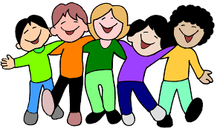

Clarke Dalton 8OM

